Beaverton Valley Times

66-year-old travelers share tales from Route 66 jaunt
Created on Thursday, 20 November 2014 00:00 | Written by Shannon O. Wells |

In-laws traveled 'America's Main Street' in 1966 Thunderbird

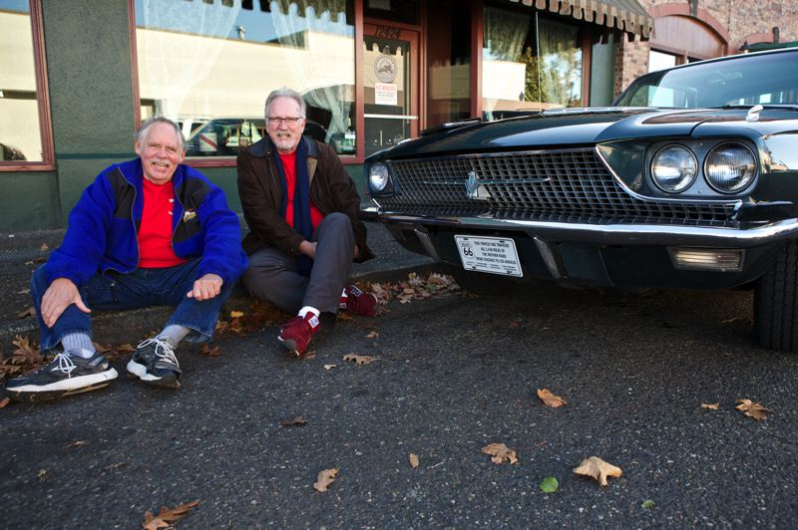
Photo Credit: TIMES PHOTO: JAIME VALDEZ - Joe Roberts and Jim Pickett show off a commemorative plate on the 1966 Ford Thunderbird that took them along the old Route 66 from Chicago to Los Angeles earlier this fall.
Joe Roberts and Jim Pickett have heard the Eagles’ infamous line about “standing on a corner in Winslow, Arizona,” from “Take It Easy” countless times since the song emerged in the summer of 1972, but they never dreamed that as seniors they’d be standing together on that very corner.
Until their Bucket List trip along U.S. Route 66, that is.
The numerous memorable stops the old friends, both 66 years old, made on their Bucket List trip along “America’s Mother Road” from Chicago to Santa Monica, Calif., in September and October included a visit to a corner in the small desert town of Winslow.
The song goes: “Well I’m a-standing on a corner in Winslow, Arizona, and such a fine sight to see. It’s a girl, my lord, in a flatbed Ford slowin’ down to take a look at me.”
Although “Take It Easy” songwriters Jackson Browne and Glenn Frey didn’t specify a corner in the iconic tune, the town of Winslow — as Roberts and Pickett learned first hand — chose one and ran with it. Marked by a detailed mural and bronze statue of the song’s lone-male protagonist, the corner is a popular tourist mecca for Route 66 explorers like Aloha resident Roberts and his Portland compadre Pickett.
“There was a Santa Fe (Railroad) train station. A guy bought it, cleaned it up and made it into a hotel with a five-star restaurant,” Roberts explained, noting the owner introduced himself. “It’s a spot you have to go to. It’s on the Bucket List. Everyone wants to stand on the corner of Winslow, Arizona. The guy had a real flatbed Ford (truck).”
Of course, seeing visitor after visitor take pictures at the celebrated corner was just one of hundreds of moments both large and small that the intrepid pair experienced as they trekked across the midwest and west in a mariner turquoise-colored 1966 Ford Thunderbird.
The T-bird carrying the retired in-laws — Roberts’ son married Pickett’s daughter eight years ago in September — pulled out of Portland on Sept. 15 bound for Chicago. From there, the guys followed Route 66, much of which was gradually overtaken by the Interstate Highway System in the 1960s — as faithfully as they could, using an “EZ 66” guidebook for just such a trip.
“A lot of it is under the freeway,” Pickett admitted of the road, which led the wave of Western migration that populated Southern California in the 1940s and ’50s. “We had the book to tell us pretty much where to turn. We tried to follow that. In one particular place, you’re driving right next to the freeway. The freeway carves through (a cut in) the mountain, but we went around it.”
While some towns along the route milk the Route 66 status for all it’s worth, other locales are mere shadows of their prosperous selves when the road was considered “America’s Main Street.”
“A lot of places are abandoned now. It’s a little heartbreaking to see now,” Roberts said, noting that elaborate historical murals along the way help keep the road’s spirit alive. “Route 66 is 90 percent murals. It’s a strong (presence) when you’re going through.”
While on their drive, which concluded on Oct. 21 at the Santa Monica Pier near Los Angeles — the original western terminus of Route 66 — Roberts and Pickett raised nearly $500 as well as awareness for the Juvenile Diabetes Research Foundation, an organization funding Type 1 diabetes research.
It helped that the Thunderbird’s exterior was adorned with their mission statement, as well as a map of their route covering the top of the broad trunk.
“We picked up a dollar here, a dollar there,” Roberts said. “At one car show, this doctor had a Thunderbird. He said he put four daughters through college who had diabetes. He handed us a $100 bill.”
While the T-Bird was not entirely cooperative along the 2,451-mile route — with warped brake rotors, a failed alternator, oil leaks and conked-out radio among the setbacks they dealt with — the fellows got along well and agreed their encounters with other travelers was the best part of the journey.
“We were in the newlywed-almost dead zone,” Pickett quipped of the young and old demographics of Route 66 travelers. “People would say, ‘Oh, I saw you a few weeks ago.’ Everybody was friendly and wanted to know our story.
“We had a great time.”
To donate, or learn more, visit tbirdtrip66.com.
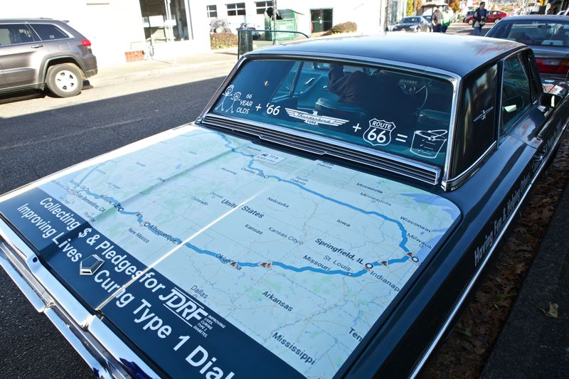
Photo Credit: TIMES PHOTO: JAIME VALDEZ - A vinyl wrap map on the trunk of a 1966 Ford Thunderbird shows the path that Joe Roberts and Jim Pickett traveled on their road trip of Route 66 from Chicago to Los Angeles.

